1. **HOSPITAL MANAGEMENT SYSTEM**

Use case diagram:

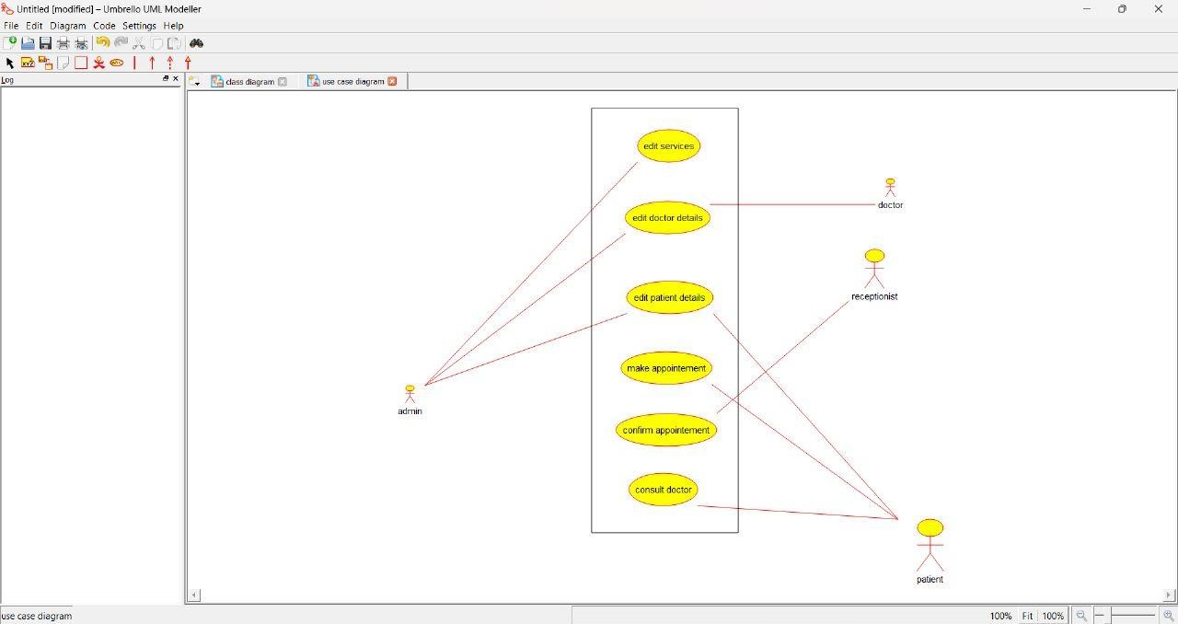

Activity diagram:

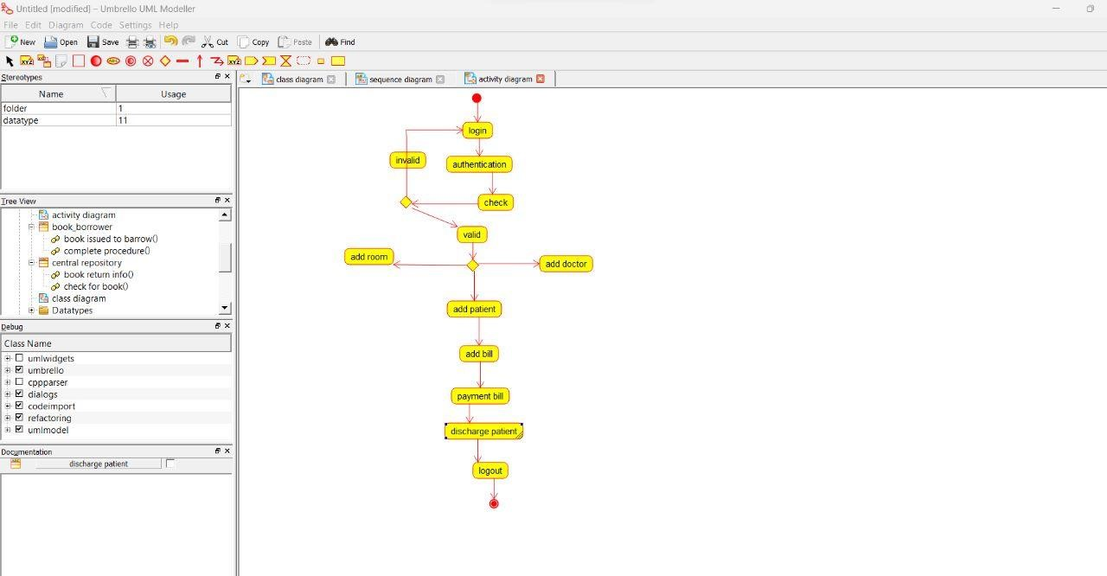

Sequence diagram:

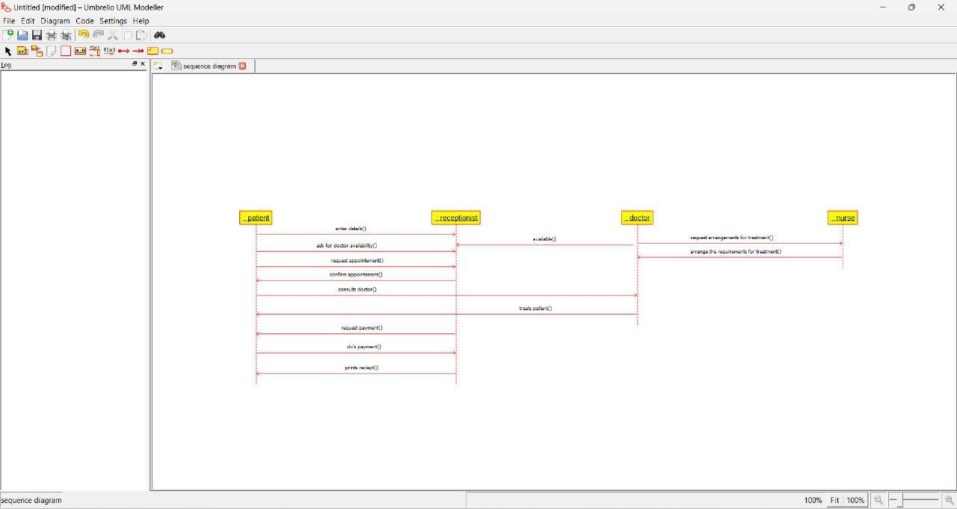

**ONLINE INSURANCE PROCESSING SYSTEM**

Use case diagram:

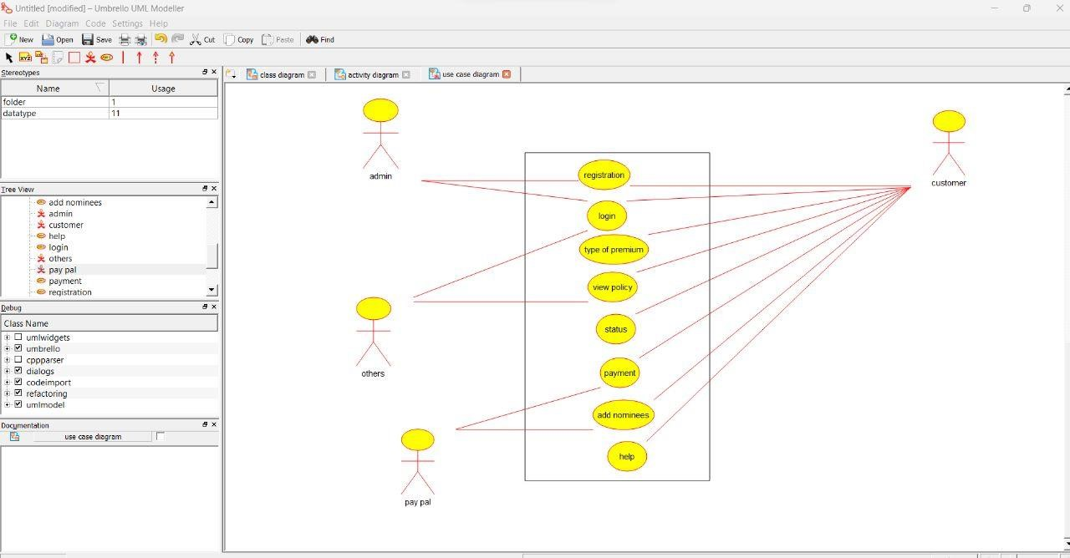

Activity diagram:

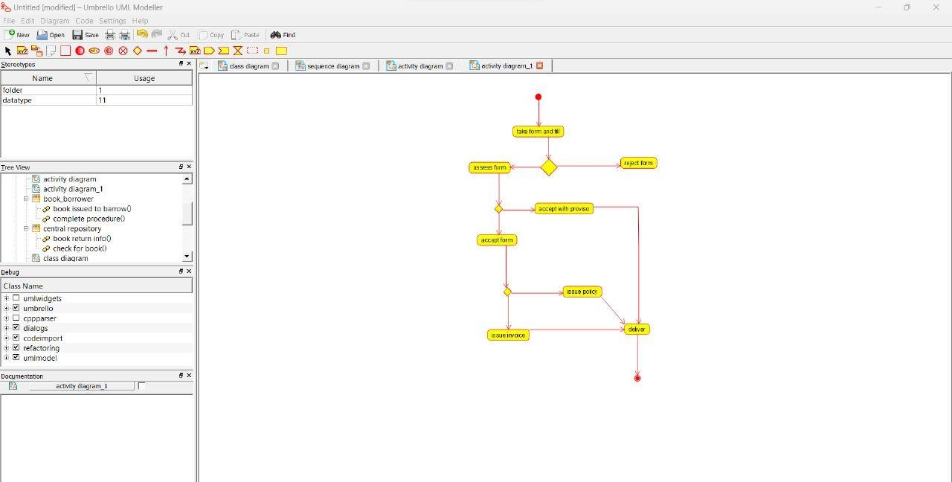

Sequence diagram:

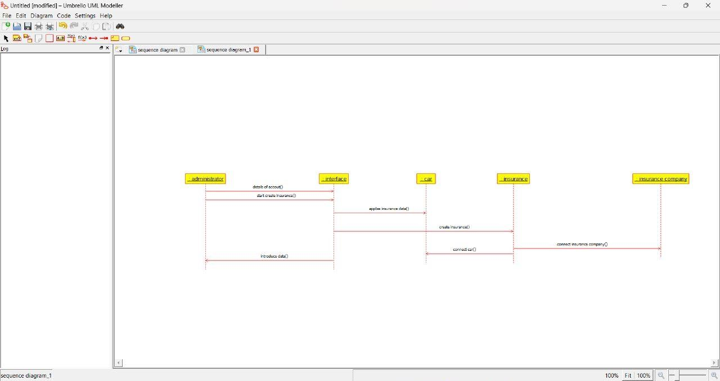

**ONLINE SHOPPING SYSTEM**

Use case diagram:

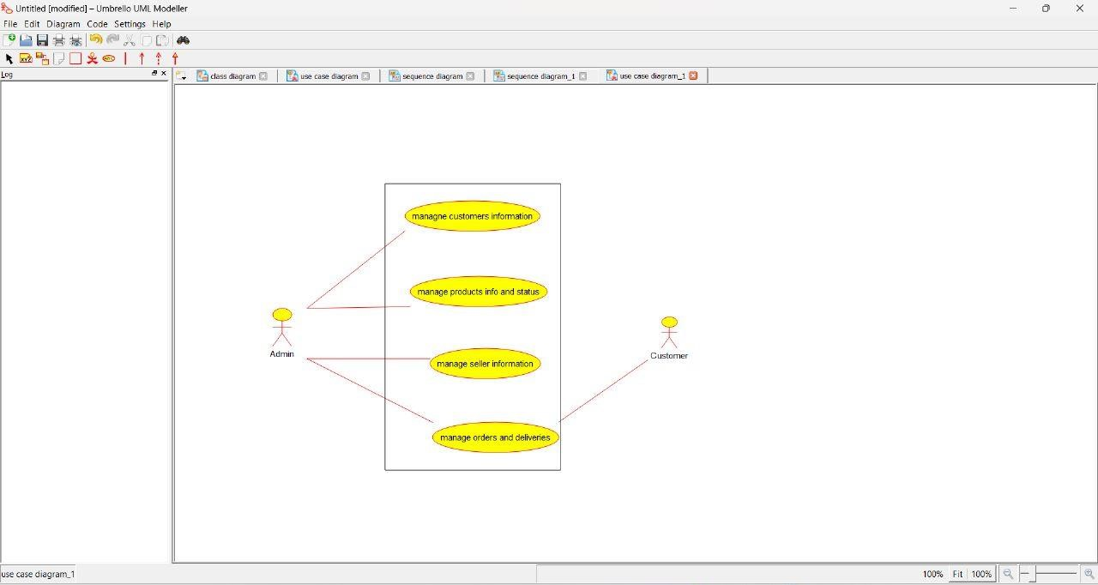

Activity diagram:

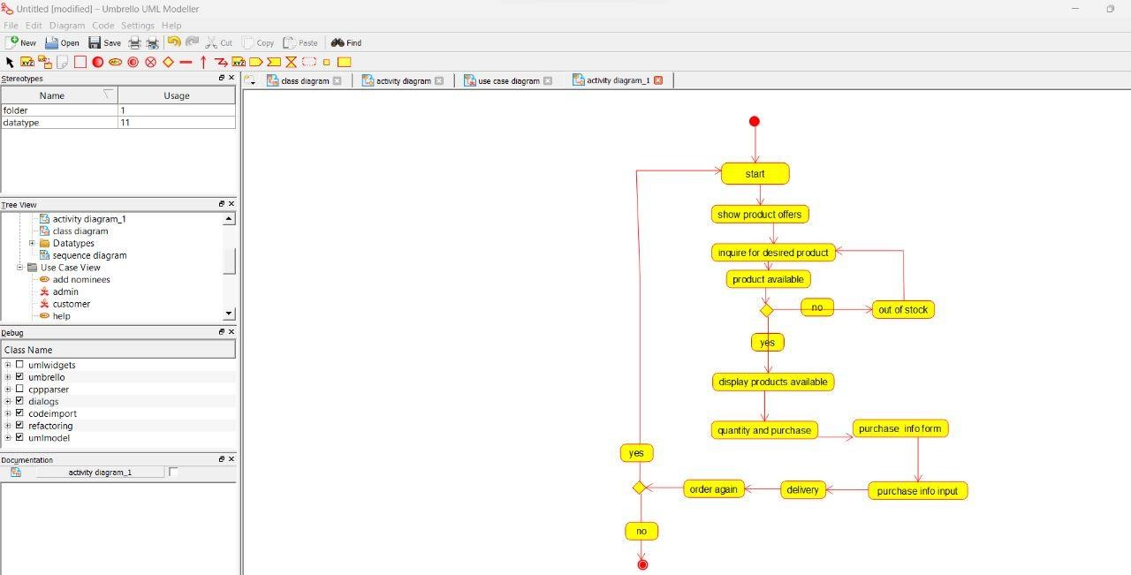

Sequence diagram:

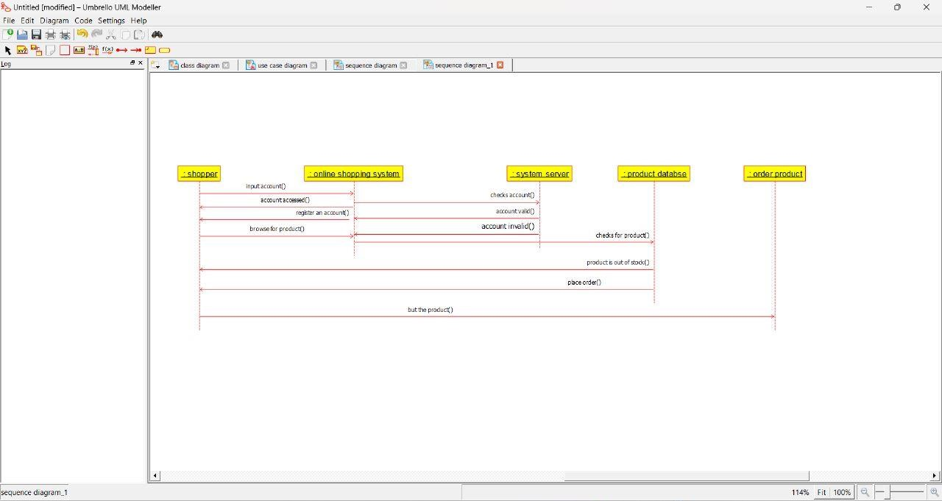

**ONLINE STOCK MARKET SYSTEM**

Use case diagram:

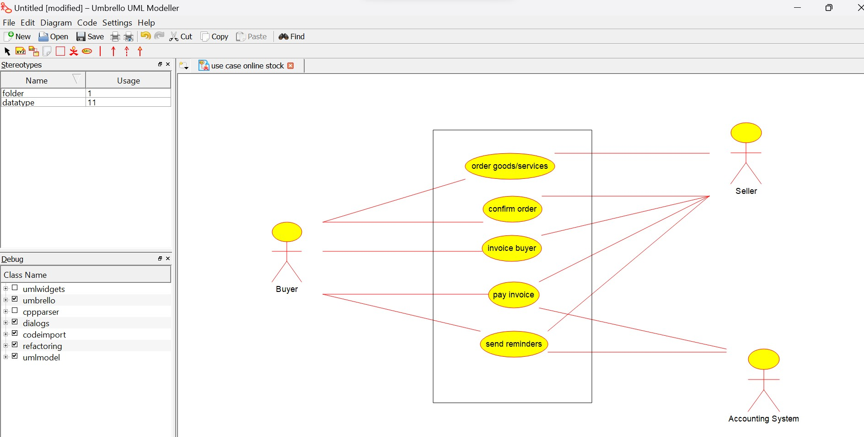

Activity diagram:

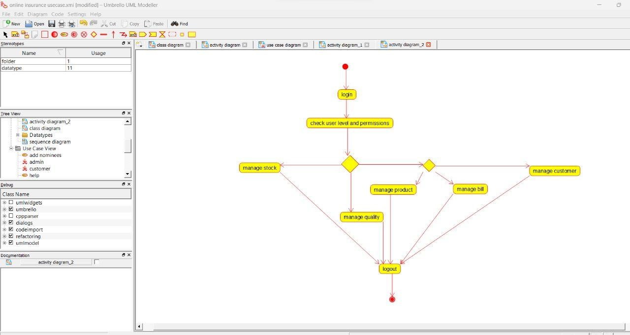

Sequence diagram:

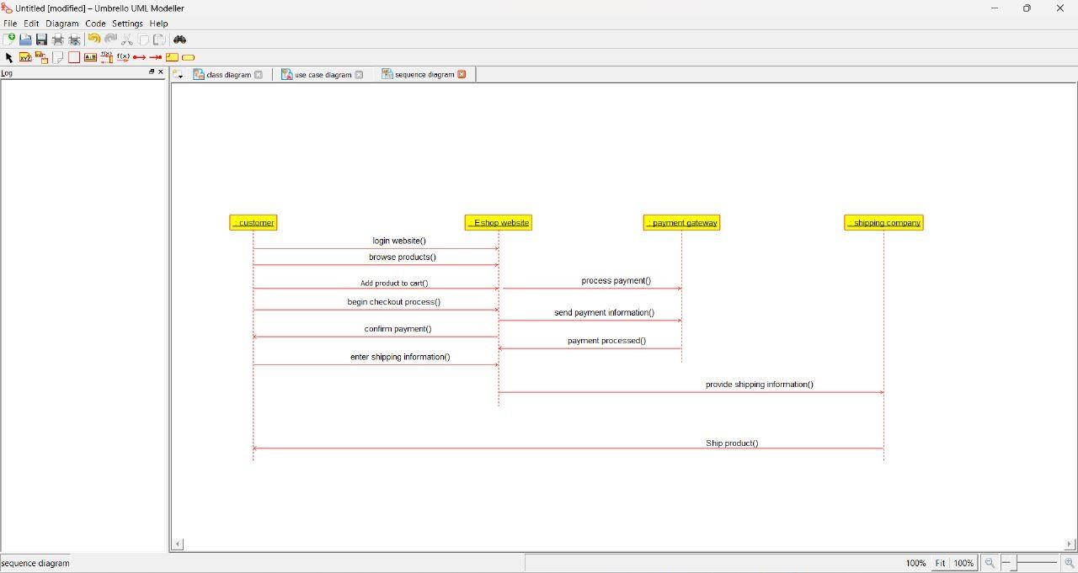

**ONLINE VOTING SYSTEM**

Use case diagram:

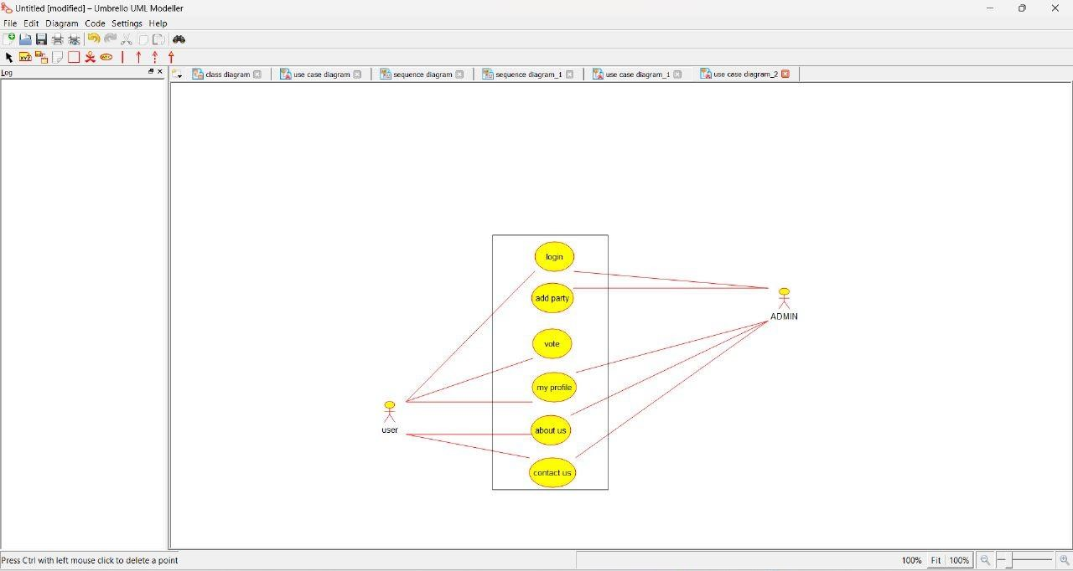

Activity diagram:

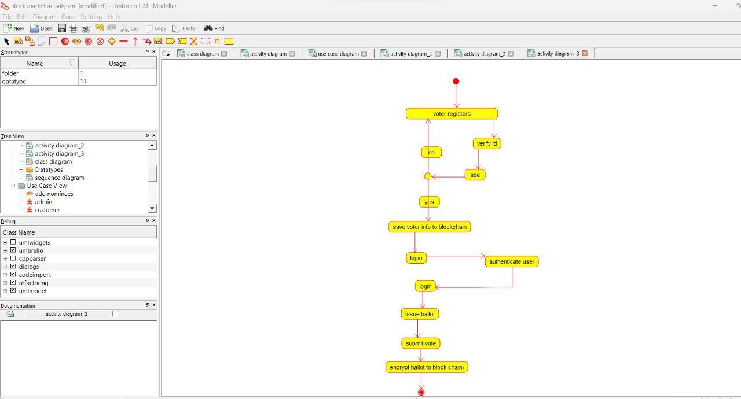

Sequence diagram:

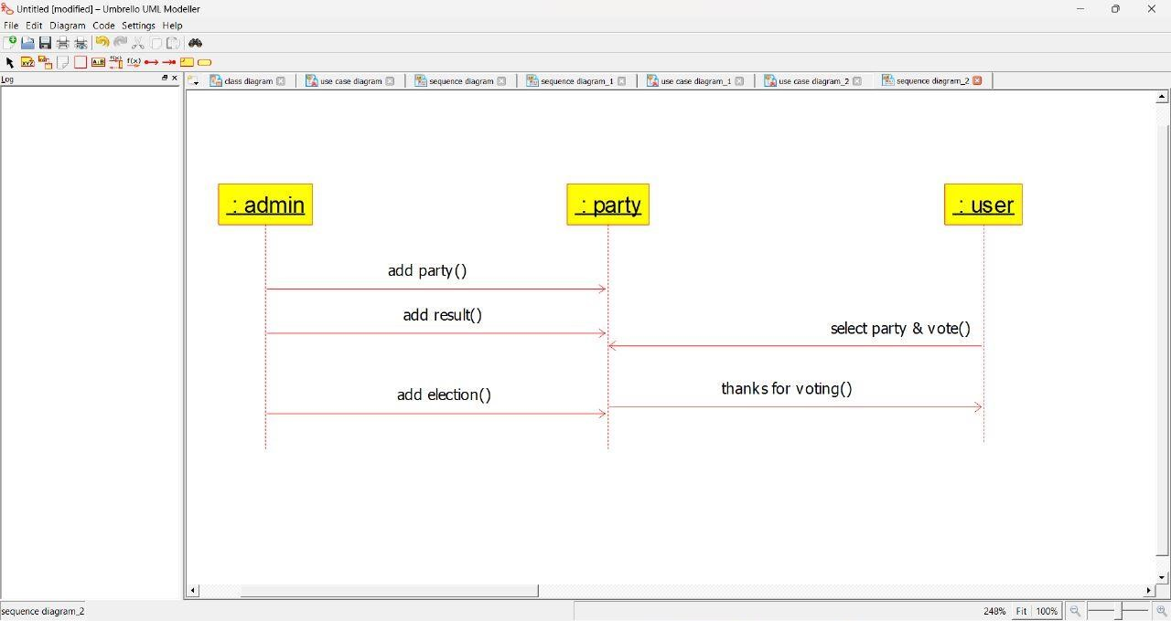

**JEWELLERY SHOP MANAGEMENT SYSTEM**

Use case diagram:

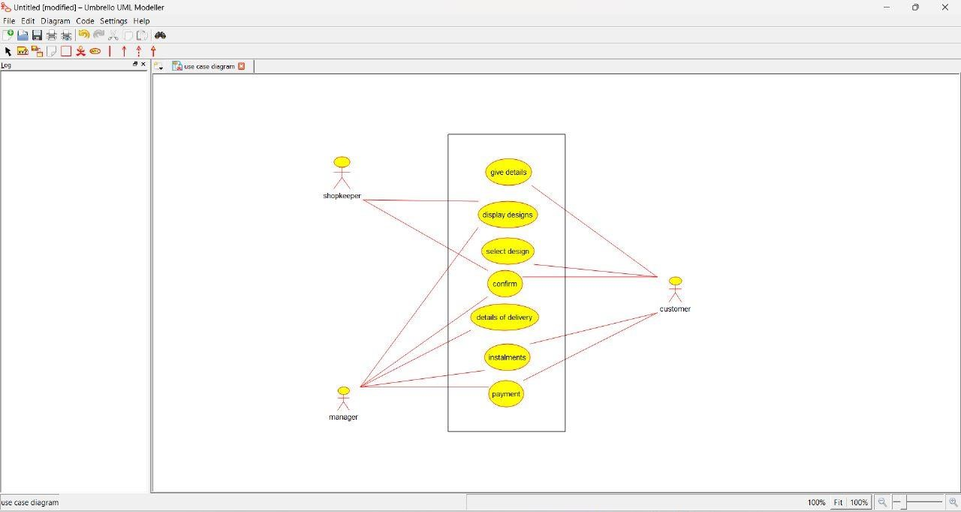

Activity diagram:

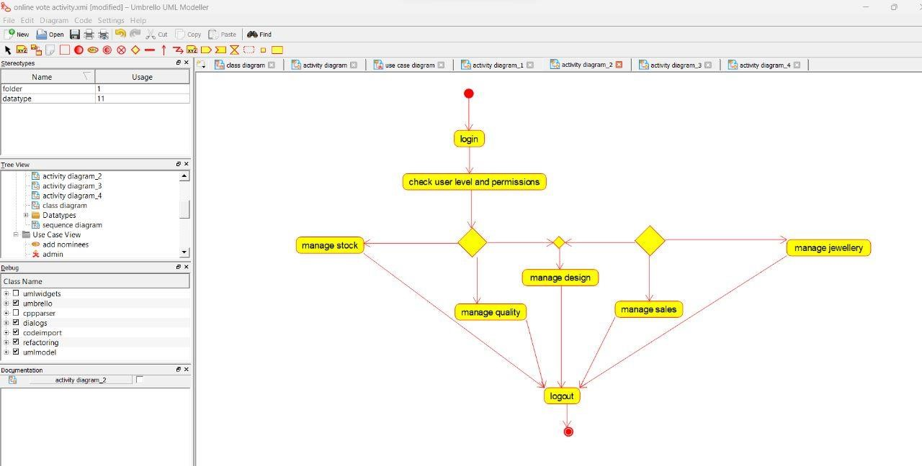

Sequence diagram:

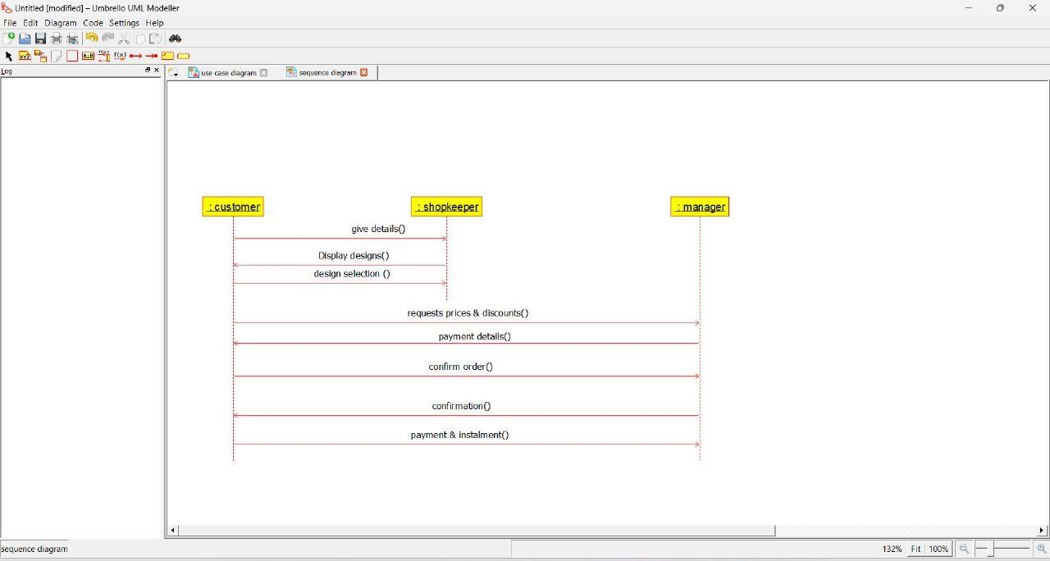

**SUPERMARKET MANAGEMENT SYSTEM** Use case diagram:

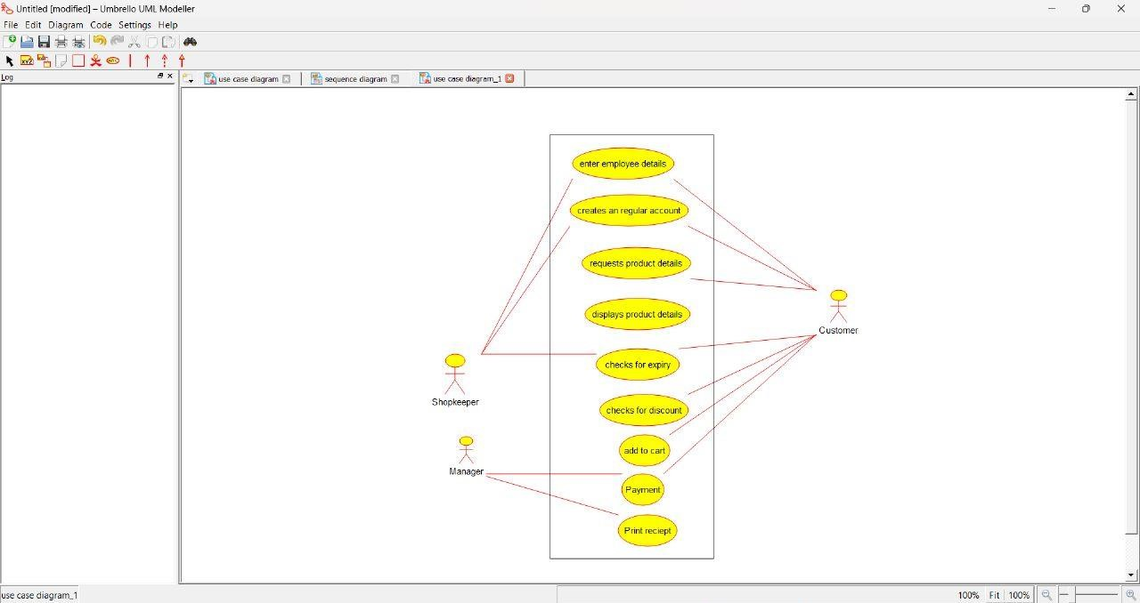

Activity diagram:

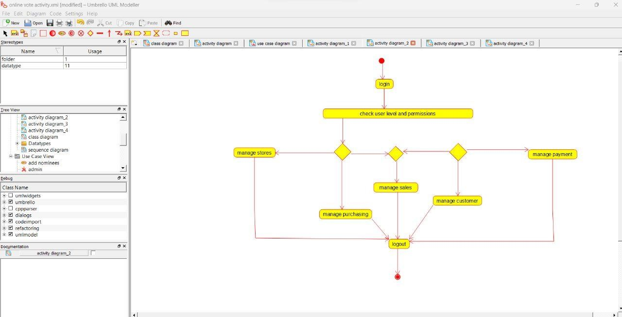

Sequence diagram:

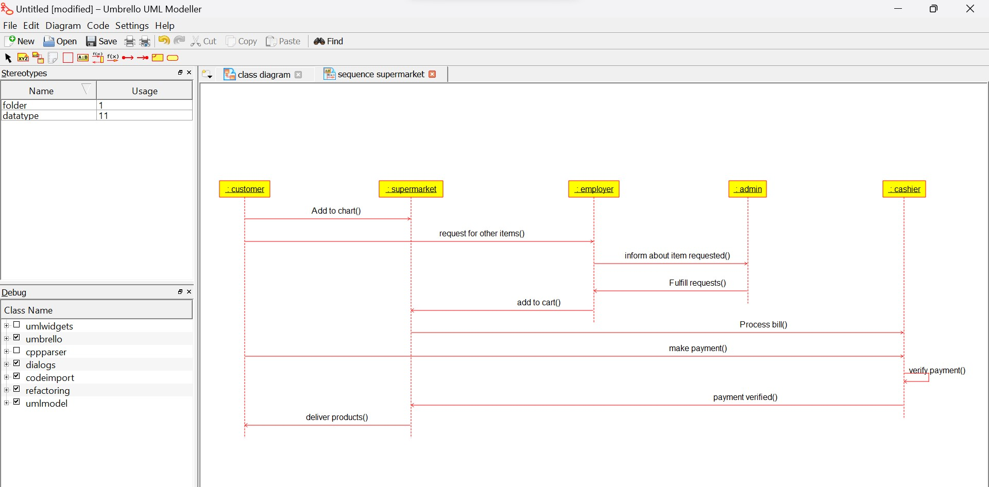

**AIRPLANE RESERVATION SYSTEM**

Use case diagram:

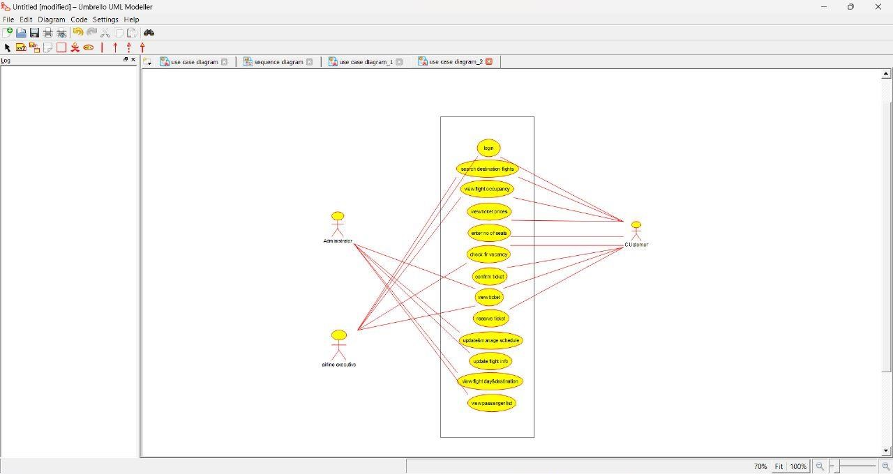

Activity diagram:

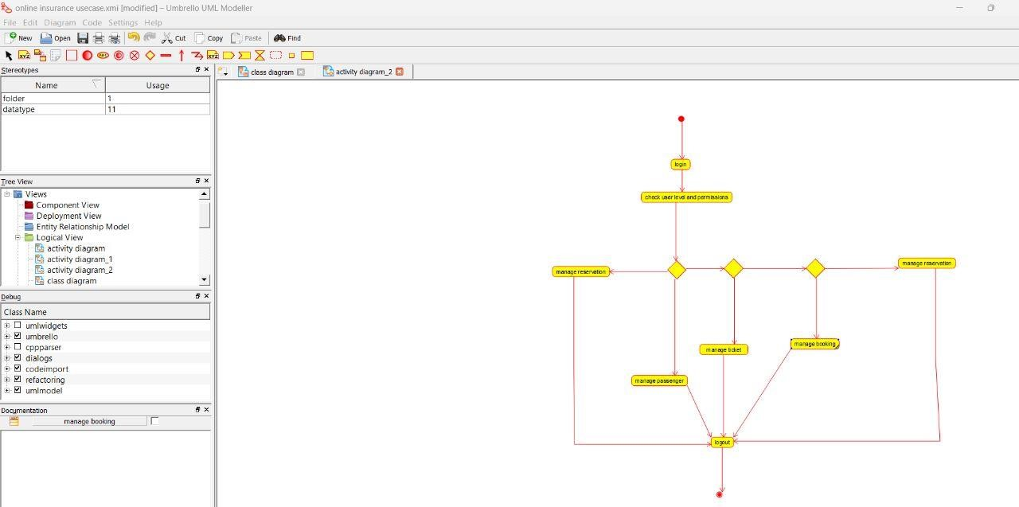

Sequence diagram:

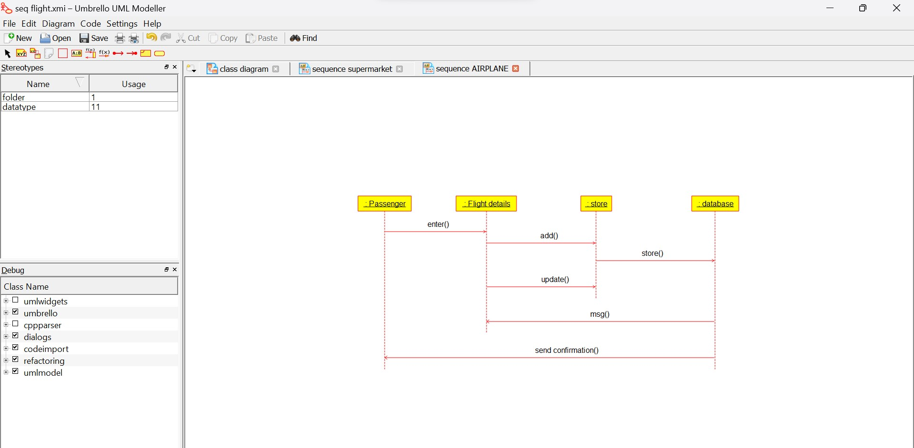

**BUS TICKET RESERVATION SYSTEM**

Use case diagram:

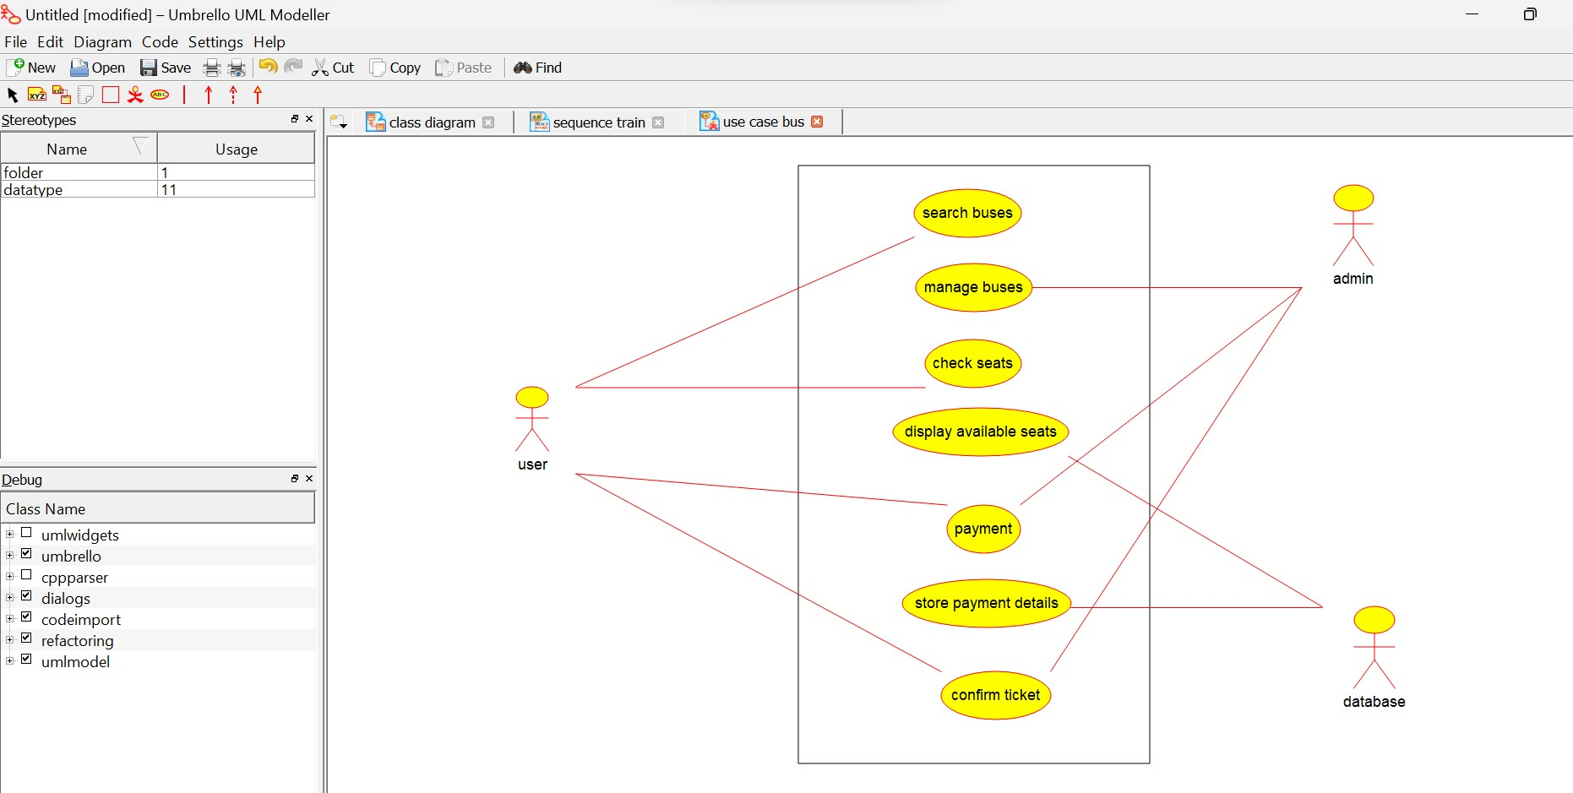

Activity diagram:

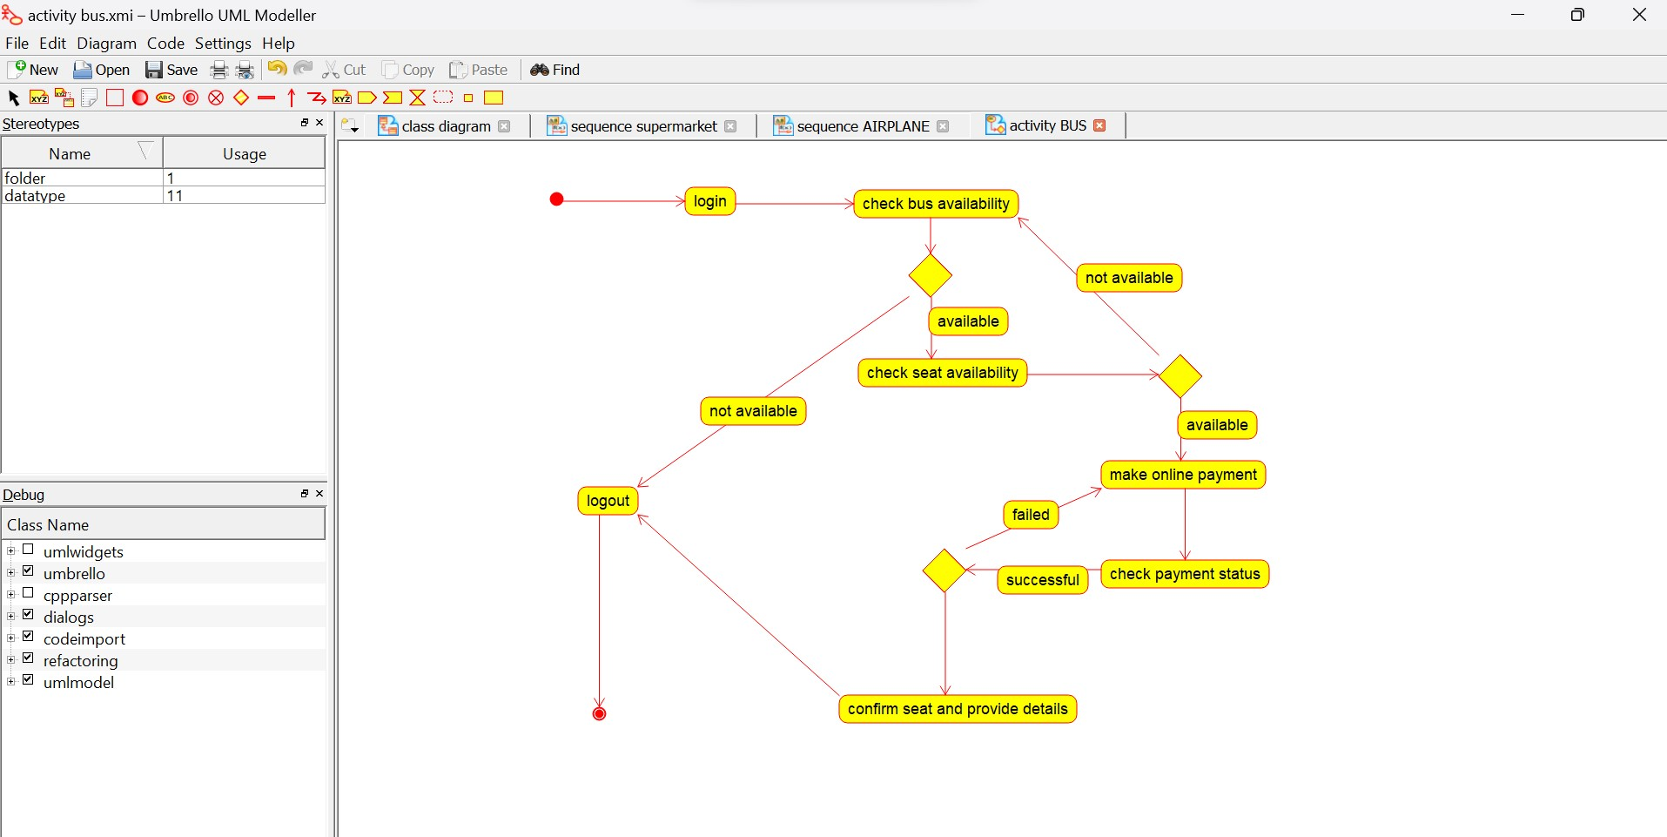

Sequence diagram:

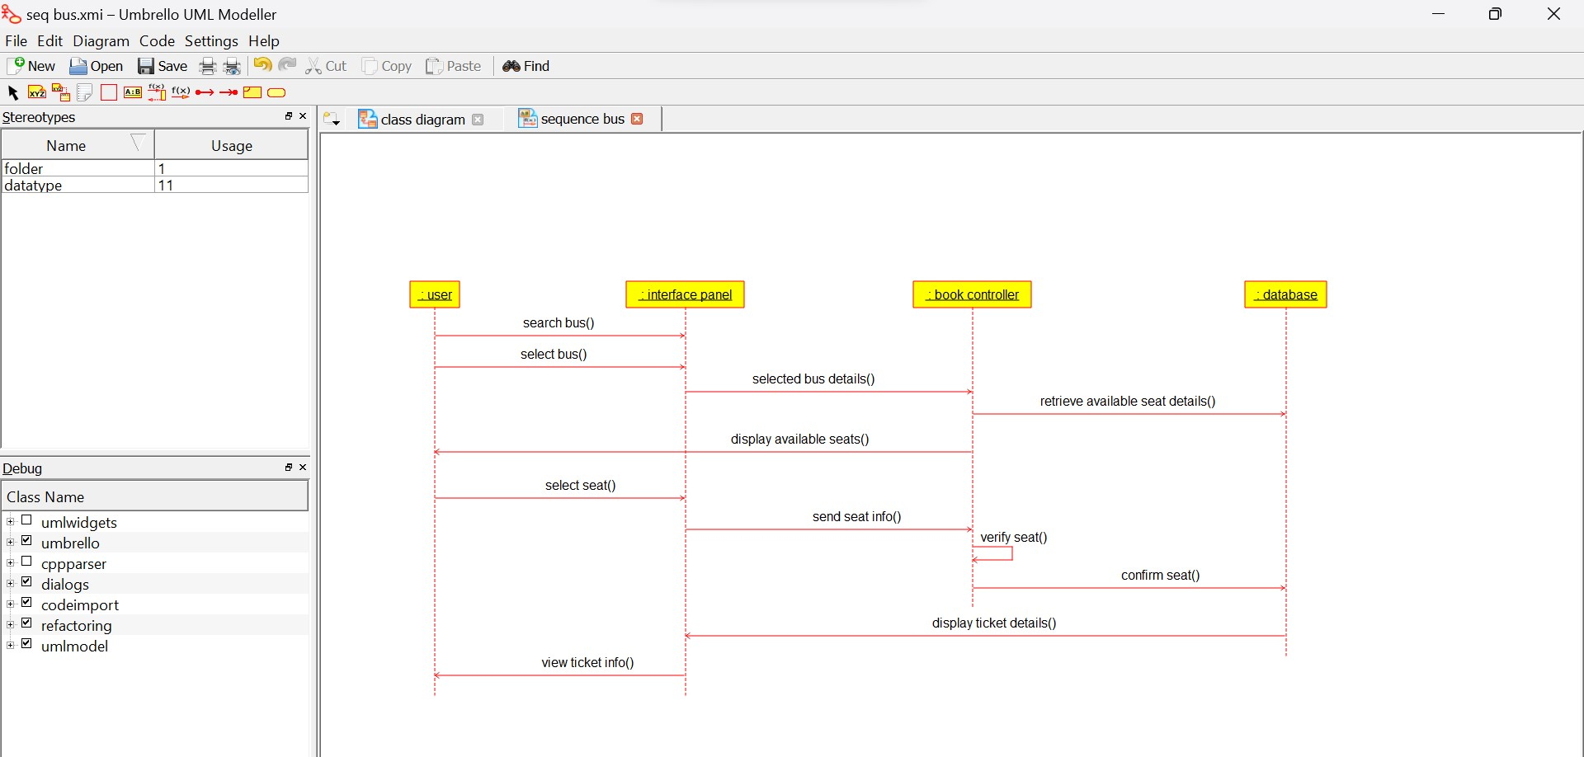

**TRAIN TICKET RESERVATION SYSTEM**

Use case diagram:

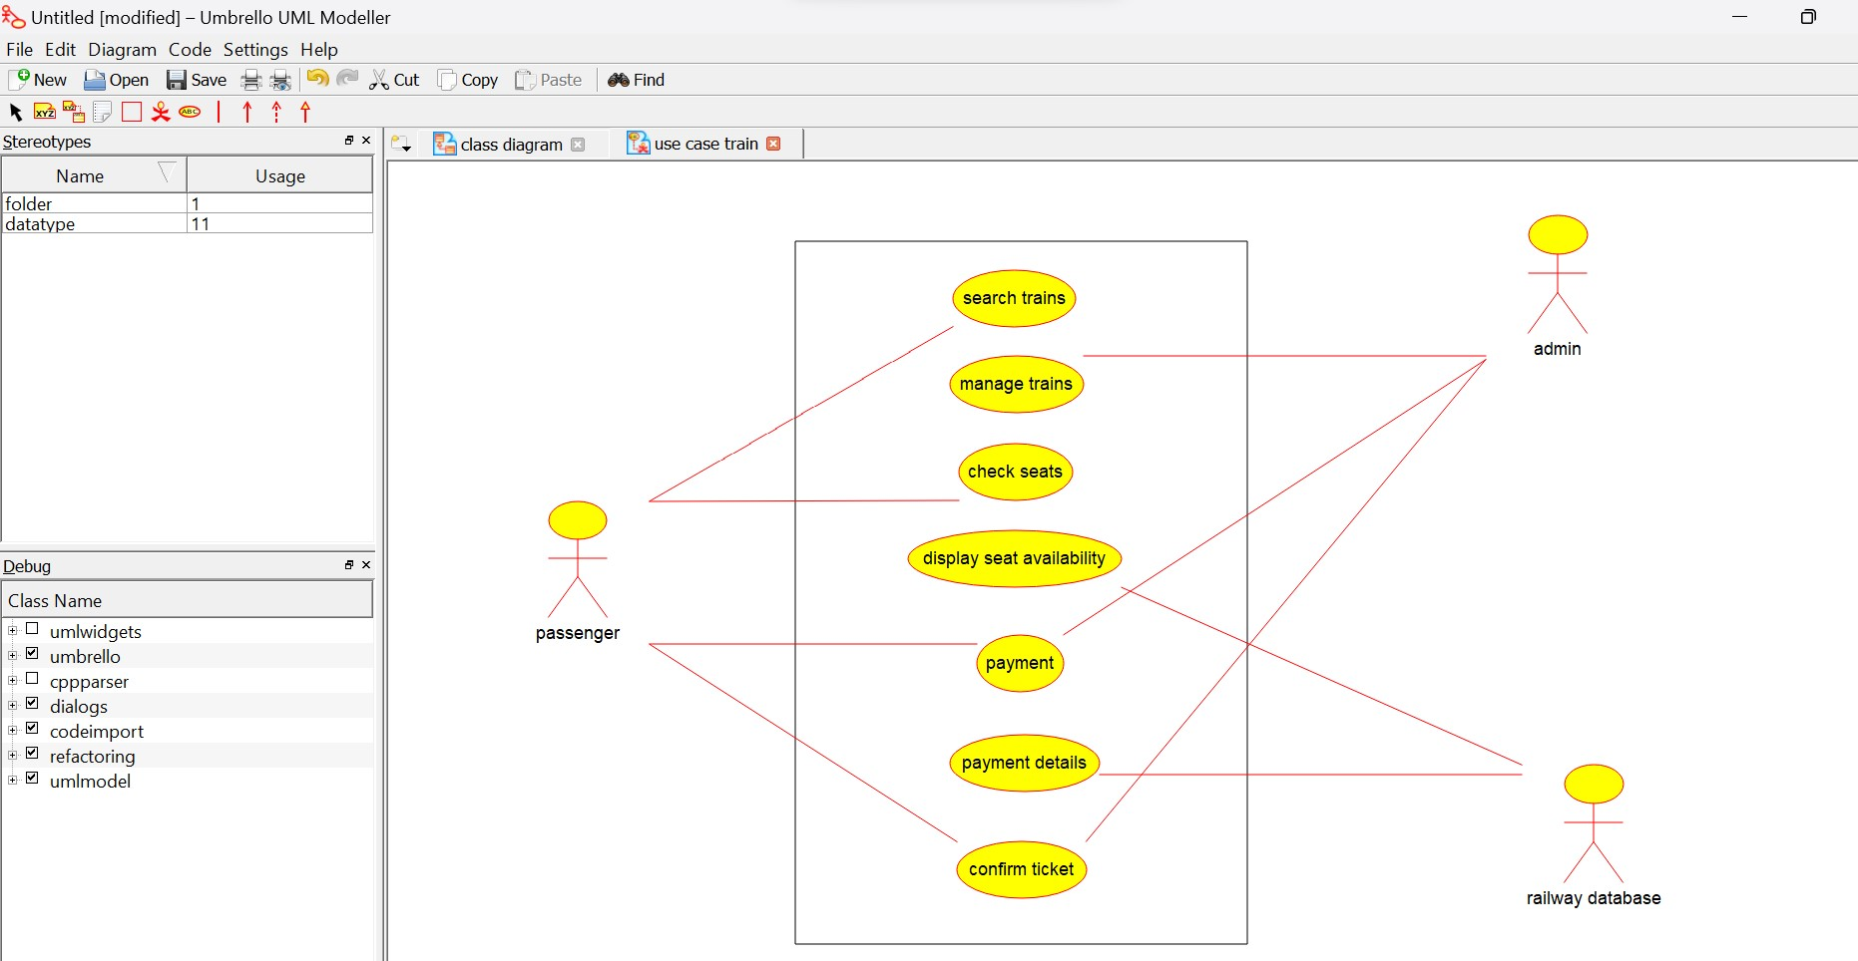

Activity diagram:

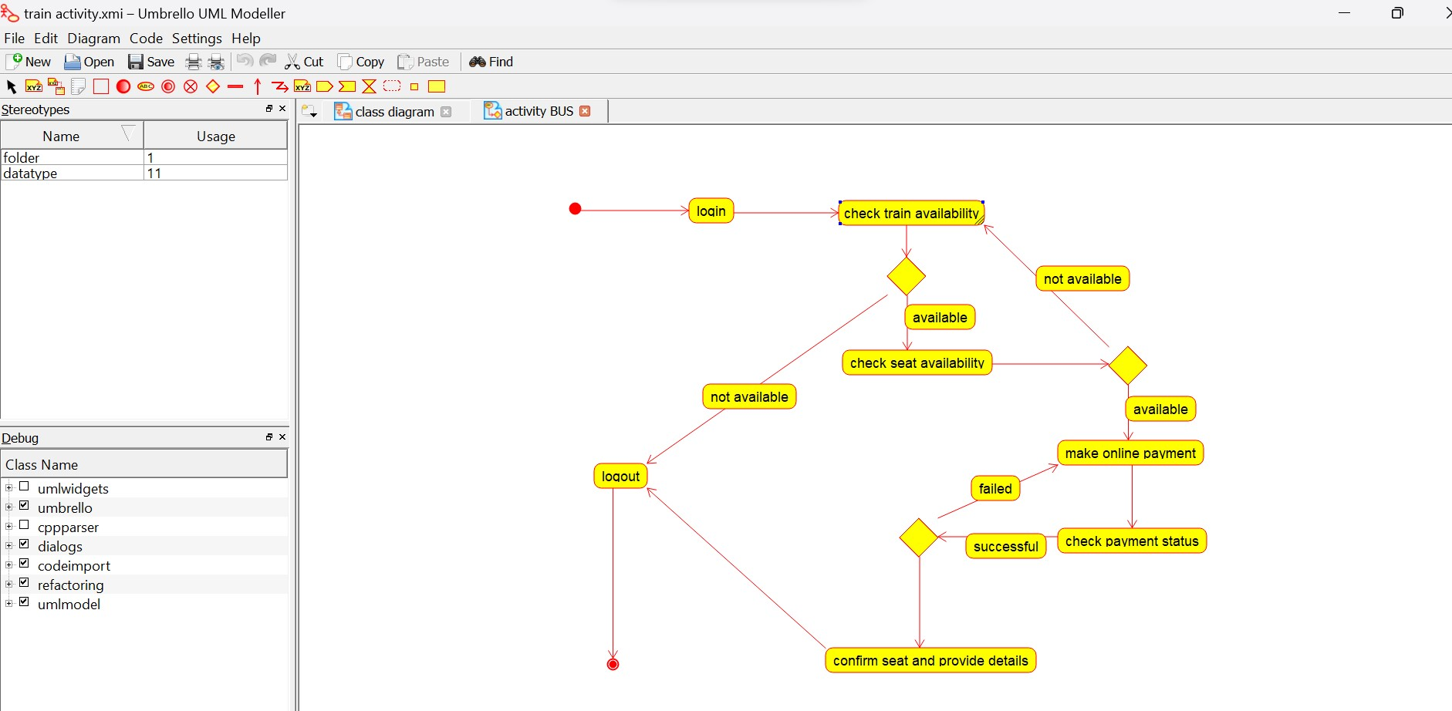

Sequence diagram:

